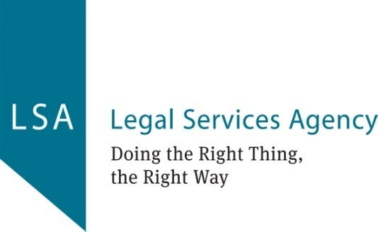

**JOB DESCRIPTION: Board Director**

**REPORTING TO: The Chair of the Board of Directors**

**ROLE:**

With fellow Board Directors to oversee the sustainable and financially stable running of the organisation in order to fulfil its charitable objectives through giving strategic direction, overseeing targets and measures, ensuring the organisation meets its plans, that it is run in an efficient manner. Individual Board Members can also expect to represent the organisation to the public and Chair, or sit, on sub-committees of the Board.

**RESPONSIBILITIES AND DUTIES:**

* To ensure that the organisation complies with its governing document, organisation law, and any other relevant legislation or regulations.
* To ensure that the organisation pursues its objectives as defined in its governing document
* To ensure the organisation applies its resources exclusively in pursuance of its objectives.
* To contribute actively to the Board role in giving firm strategic direction to the organisation, setting overall policy, defining goals, setting targets and evaluating performance against agreed targets.
* To safeguard the good name and values of the organisation.
* To represent the organisation at functions and meetings as appropriate.
* To declare any conflict of interest while carrying out the duties of a Board member.
* To be collectively responsible for the actions of the organisation and other Board members.
* To ensure the effective and efficient administration of the organisation.
* To abide by the policies of the organisation.
* To ensure the financial stability of the organisation.
* To protect and manage the property of the organisation and to ensure the proper investment of the organisation's funds.
* To make sure the organisation is properly insured against all reasonable liabilities.
* To appoint and support the Executive officers and monitor their performance.
* To attend meetings, and to read papers in advance of meetings.
* To attend sub-committee meetings as appropriate.
* To participate in other tasks as arise from time to time, such as interviewing new staff, helping with fundraising.
* To keep informed about the activities of the organisation and wider issues which affect its work.
* To maintain confidentiality about discussions in Board / committee meetings, which are understood to operate under the Chatham House Rule, unless authorised by the Chair to speak of them externally.

In addition, each Board Director is expected to use any specific knowledge or experience they have to help the Board reach sound decisions. This will involve scrutinising Board papers, leading discussions, focusing on key issues, and providing advice and guidance requested by the Board on new initiatives, or other issues relevant to the area of the organisation's work in which the trustee has special expertise.

**BOARD DIRECTOR SPECIFICATION:**

* Integrity
* A commitment to the organisation and its objectives
* An understanding and acceptance of the legal duties, responsibilities and liabilities of a charitable company board member
* A willingness to devote the necessary time and effort to their duties as a Board Director
* Strategic vision
* Good, independent judgement
* An ability to think creatively
* Willingness to speak their mind
* An ability to work effectively as a member of a team

**SKILLS REQUIRED ACROSS THE BOARD (it would be helpful though not essential if applicants have skills/experience in one of the following)**

* Setting targets, monitoring and evaluating performance and programmes in commercial and non-profit organisations
* Financial management
* Knowledge of the type of work being done by the organisation
* Legal matters related to running a charity and to public law
* Fundraising
* HR and people management including a knowledge of employment legislation and recruitment
* Public relations
* Business development
* Marketing
* Digital development and IT management
* Computers and information technology
* Campaigning
* Policy development
* Change management