Access to justice for neurodiverse people and people with hidden disabilities
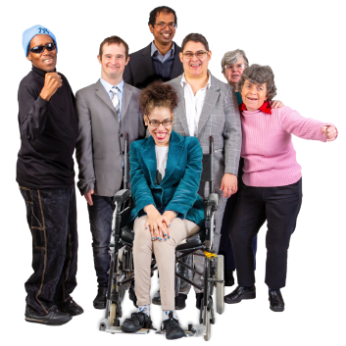

Copyright images © Photosymbols. Prepared by Disability Equality Scotland
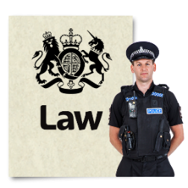  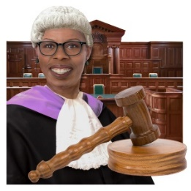 | Access to justice means being treated fairly by the law, and having access to police, courts and organisations that give advice.
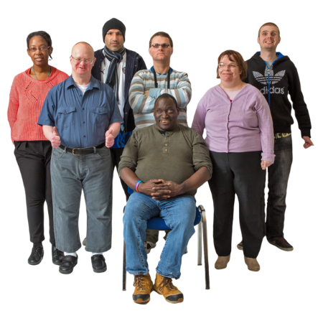 | Neurodiverse describes people who have differences in their brain and they experience the world differently.  It includes:  - autistic spectrum disorder  - ADHD  - dyslexia  - Tourette’s syndrome
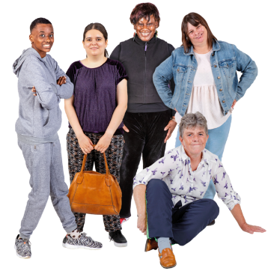 | Hidden disabilities are ones that you cannot see straight away like:  - mental health  - very bad pain or tiredness  - a learning disability  - a sensory impairment like hearing loss or sight loss
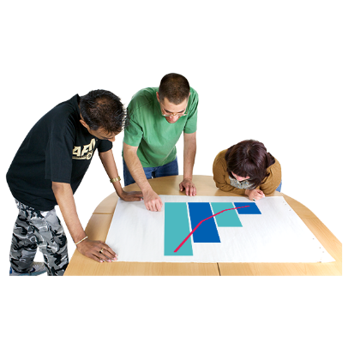 | The Legal Services Agency is doing research on how neurodiverse people and people with hidden disabilities get access to justice in Scotland.  Research means looking closely at facts, figures and information about something.
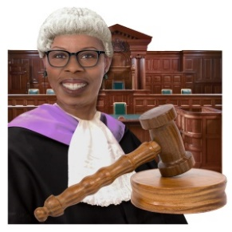 | We are very interested in hearing from anyone who has needed to get a solicitor or go to court and who sees themselves as:  - neurodiverse  - or having a hidden disability
The survey has 27 questions.

Click on the box of the answer you agree with and a tick will appear. ☐

If you change your mind you can click on it again to untick it.

If you have more to say type your answer in the ‘Type your answer here’ spaces.

The space will get bigger as you type.

Miss out a question if you do not know the answer.

You do not have to answer a question if you do not want to.

 | - Do you see yourself as neurodiverse or as having a hidden disability?
 | Yes | ☐
 | No | ☐
- If you feel comfortable to tell us, please tell us more about your neurodiversity or your hidden disability.

Type your answer here:

- Have you ever needed to get legal advice?

This could be from a lawyer or solicitor or an organisation like a law centre, or Citizens Advice Bureau.

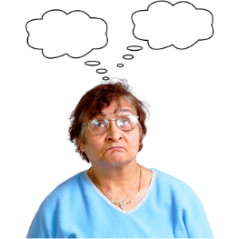 | Yes | ☐
 | No | ☐
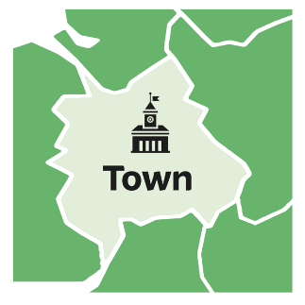 | - What town or city was this in?  Type the name here:
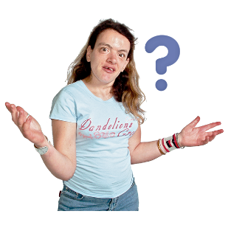 | - What area of law was it about?  Type it here:
 | - Did you find someone to give you advice?
 | Yes | ☐
 | No | ☐
 | 7. Was there anything that made it difficult to get legal advice?
 | Yes | ☐
 | No | ☐
- If you answered ‘yes’ please tell us more about what made it difficult.

Type your answer here:

 | - Were you happy with the outcome – the way things turned out?
 | Yes | ☐
 | No | ☐
- Please tell us more about this.

Type your answer here:

 | - Have you ever needed to take someone to court or to a tribunal?
 | Yes | ☐
 | No | ☐
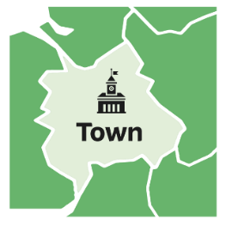 | - What town or city was this in?  Type the name here:
- What area of law was it about?

Type your answer here:

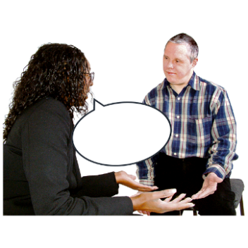 | - Were you represented by a lawyer?
 | Yes | ☐
 | No | ☐
 | - Was there anything that made it difficult before, during or after you were in court?
 | Yes | ☐
 | No | ☐
- If you answered ‘yes’ please tell us more about what made it difficult.

Type your answer here:

 | - Were you happy with the way things turned out?
 | Yes | ☐
 | No | ☐
- Please tell us more.
Type your answer here:

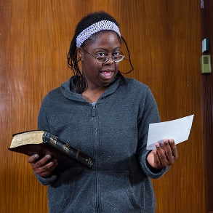 | - Have you ever needed to go to a court or tribunal in a criminal case?
 | Yes | ☐
 | No | ☐
- What town or city was this in?

Write the name here:

 | - What area of law was involved?
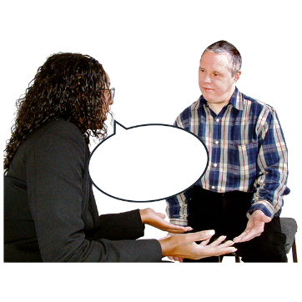 | - Were you represented by a lawyer?
 | Yes | ☐
 | No | ☐
 | - Was there anything that made it difficult for you before, during or after being in court?
 | Yes | ☐
 | No | ☐
- Please tell us more.

Type your answer here:

 | - Were you happy with the way things turned out?
 | Yes | ☐
 | No | ☐
- Please tell us more.

Type your answer here:

- Is there anything else you would like to tell us about what makes it difficult for neurodiverse people and people with hidden disabilities to get legal advice and access to justice in Scotland?

Type your answer here:

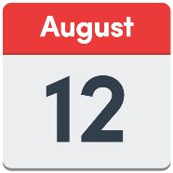 | Save a copy of this document and email it to: mail@lsa.org.uk .
Thank you for taking the time to complete this survey.
Your answers will help us understand what makes it difficult for neurodiverse people and people with hidden disabilities to get access to justice

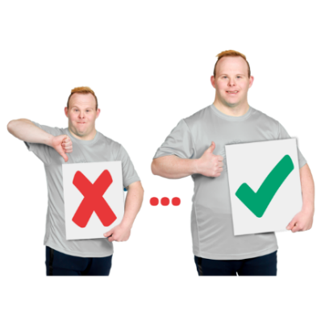 | We will use the results to help make justice services in Scotland better.

Copyright images © Photosymbols. Prepared by Disability Equality Scotland

