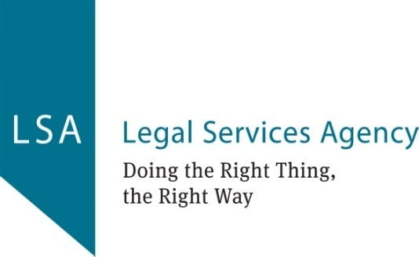 | Board of Directors  Trustee Recruitment Pack

About LSA
Legal Services Agency (LSA) is Scotland's largest law centre and is committed to tackling the unmet legal needs of those in disadvantage. Established in 1990, we have a 30-year legacy of providing legal advice and representation addressing the effects of poverty, disadvantage and discrimination and enhancing legal education.
We have offices in Glasgow, Inverclyde and hold outreach surgeries in Edinburgh and other areas, providing services to individuals and organisations throughout Scotland. Our team has accumulated significant experience in areas of social welfare law, all areas of housing law, mental health, discrimination, welfare benefits, community care and criminal injuries compensation. Staff have been working in a hybrid model since easing of restrictions arising from COVID-19. Work is underway to consider how we apply the successful learnings of this experience in our future operating model.
We are a major contributor in legal education, and undertake research, produce publications and deliver a wide range of seminars and training programmes.
We are pleased to have launched our new website last year and our Annual Report provides further details of the exceptional commitment of our team and the impact of our work over the last year in what has continued to be unusual times.

The role of our Board
Legal Services Agency Limited is a Scottish charity and a company limited by guarantee. The organisation works in partnership with Brown & Co. Legal LLP which supplies all of the organisation’s legal work.

The Board of Directors are made up of annually elected members of the community, who donate their time on a voluntary basis, offering a breadth of knowledge from the private, public, and voluntary sector. The Convener, Vice-convener, Treasurer are elected on an annual basis from among the members of the Board. We are a membership organisation and invite nominations from our Members. In addition, the Board of Directors are able to appoint up to five ‘Appointed Directors’ who are not members.

We have highly skilled and committed Trustees with wide range of backgrounds: private, public, third sector and academia. Our Trustees are volunteers, however, we reimburse travel and other expenses incurred in carrying out the role. For the avoidance of any confusion, the reference to ‘Trustees’ and ‘Directors’ is interchangeable and refers to members of our Board of Directors.

Our Trustees are responsible for overall governance, financial management and strategic direction of LSA.
- Trustees ensure we have a clear strategy, and our work and goals are in line with our vision.
- Our Trustees are responsible for our effective governance, ensuring we meet our legal obligations and our financial resources are managed efficiently.
The Board normally meets six times per annum to ensure appropriate governance and guide our strategy at our Glasgow Offices based at Fleming House, 134 Renfrew Street, Glasgow G3 6ST.
The Executive and Finance Committees, Sub-Committees of the Board meet in alternate months between Board meetings to provide more detailed consideration of matters as designated by the Board of Directors.
Directors are able to participate in meetings remotely via telephone conferencing or online mediums. Over the last two years, due to COVID-19 restrictions, all Board and Sub-Committee meetings have been held online. We hope to be able to meet in-person later this year, taking account of Government guidance.
Role of Trustees
- Act in the best interest of LSA, making sure all decisions are in accordance with LSA’s charitable objectives as stated in our governing document.
- Regular attendance at Board meetings and Sub-Committees as required.
- Active contribution at Board meetings, preparing well for meetings reviewing reports and minutes in advance of meetings.
- Act with due diligence taking care of LSA’s affairs ensuring the charity complies with the provisions of The Charities and Trustee Investment (Scotland) Act 2005 and other relevant legislation.
- Apply relevant skills, working constructively with fellow Trustees and LSA team to achieve shared goals.
- Ability to analyse risks and opportunities and take a balanced approach to both.

Further details of Charity Trustees’ responsibilities can be found on OSCR guidance and good practice for Charity Trustees

We welcome applications from people with experience in:
- Financial Management
- Policy development and campaigning activity
- Understanding and or experience of working in law or advice sectors
- HR and People management
- Understanding of or experience of working central government and local authority

Benefits of being a Trustee
- Support the third sector and a cause that you care about
- Build and share strategic experience and skills
- Develop and share your professional networks
- Develop and share skills and experience

Application process
Please complete the short application form addressing the following: -
- Your interest in becoming a Trustee of LSA
- Details of two referees
Please submit the completed application form together with your CV to mail@lsa.org.uk.

Please contact our Chief Executive. Aaliya Seyal. on 0141 353 3354 if you wish to discuss the role.

Your application will be considered by LSA’s Board’s Executive Committee with support from LSA Team. The Selection Panel will consider your interest in LSA’s objectives and the skills and experience you demonstrate in your application and CV. The Selection Panel will consider the areas of skills identified as important and complimentary for the Board to be run in an effective manner.

You may be invited to a discussion with Board if your application is considered for appointment. References will be sought with prior permission.

The Board of Directors will consider the recommendations of the Selection Panel and is responsible for the final appointment of ‘Appointed Directors’.

Board of Directors
Application Form

Name
Address
Email address
Telephone number

- In no more than 500 words please describe why you want to be a volunteer Director on the Board of Legal Services Agency.
- Details of two Referees

Name: | Name:
Job Title: | Job Title:
Organisation: | Organisation:
Address: | Address:
Contact Tele No. | Contact Tele No.
Email address | Email address
In what capacity does he/she know you? | In what capacity does he/she know you?
References will be sought with prior permission.

Please return completed form to: mail@lsa.org.uk

